**Assignment 7 – April 13**



My output:

Project Flow:

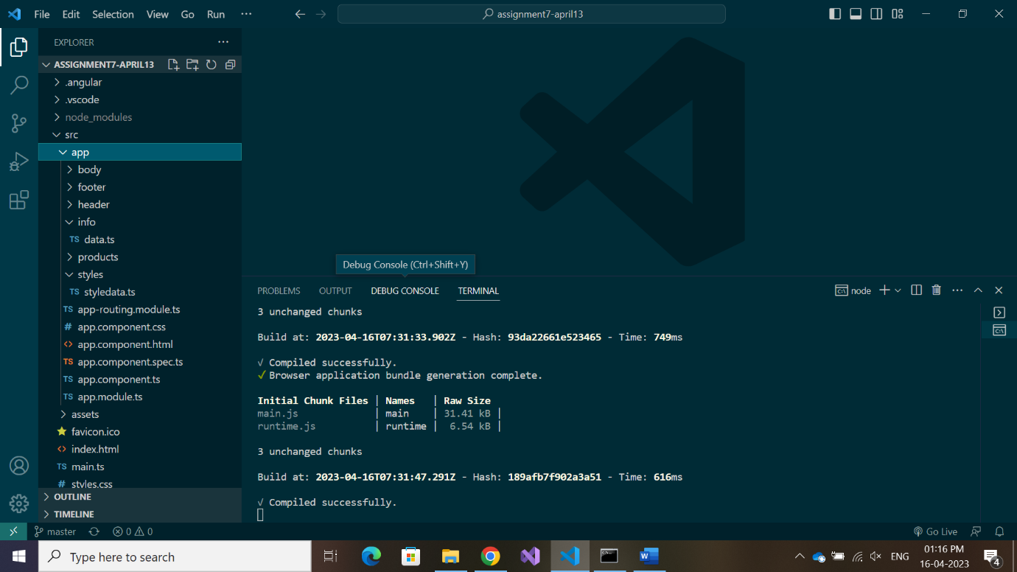

Components created for the project: header, body, products and footer.

Typescript file named “styledata.ts” is created for handling styles, similarly “data.ts” is created under the folder “info” to store and export data.

data.ts:

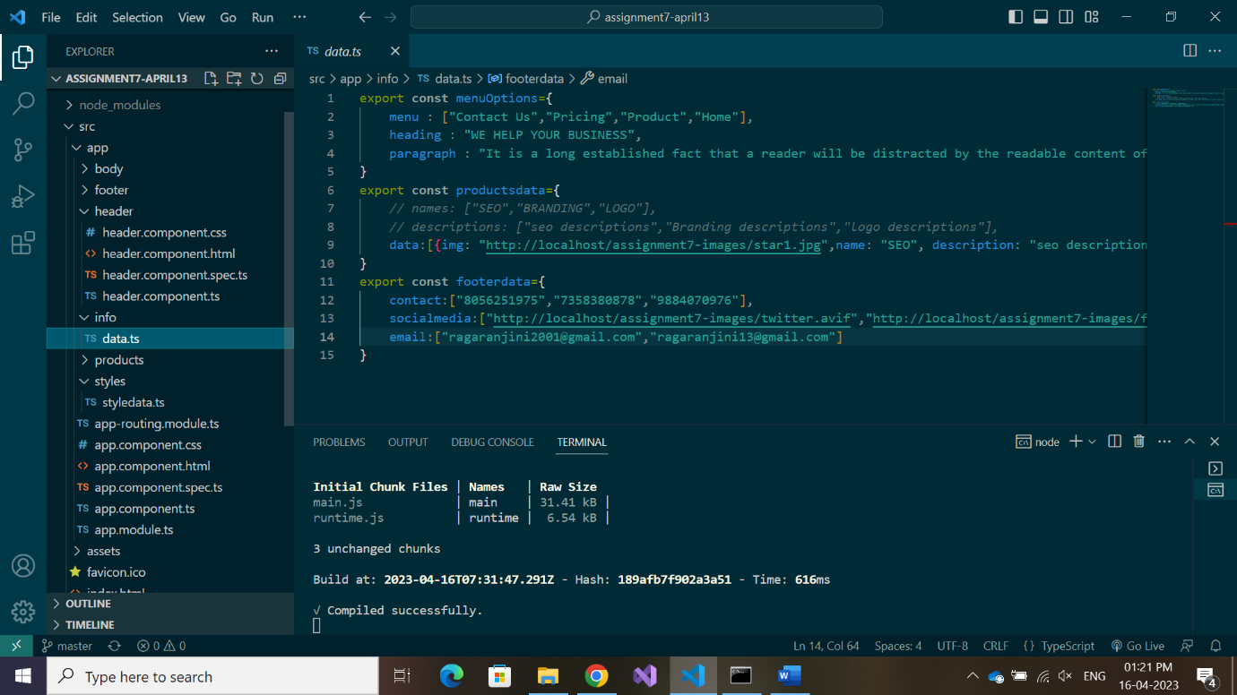

Exports ‘menuoptions’, ‘productsdata’ and ‘footerdata’.

app.component.ts:

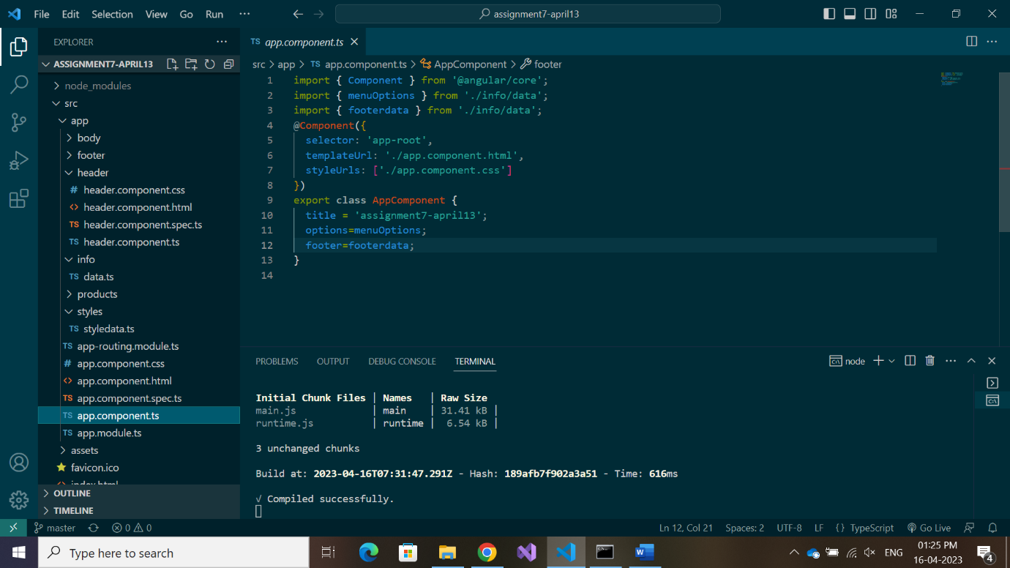

‘menuoptions’ and ‘footerdata’ are imported here and sent to respective components namely header, body and footer via app.component.html and respective component’s ts file using ‘@Input()’.

products.component.ts:

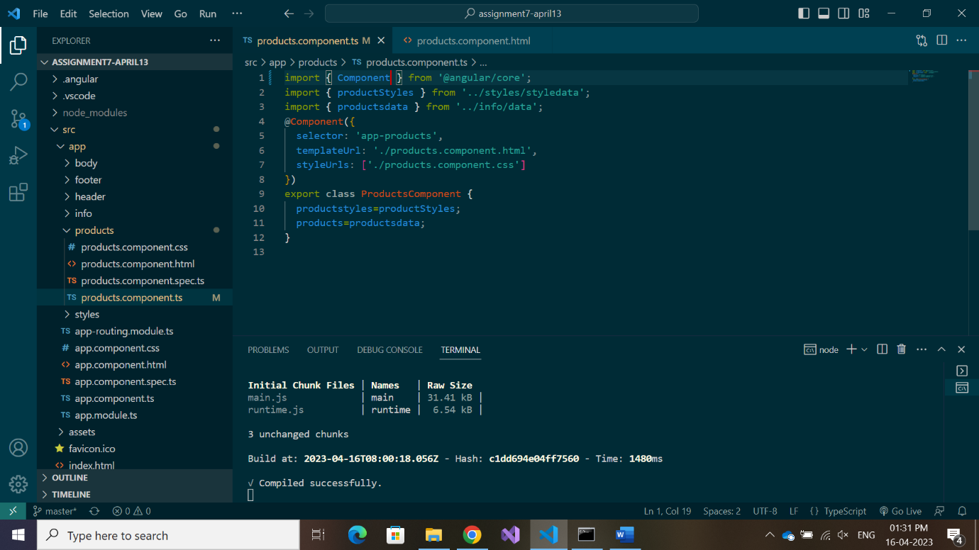

“productsdata” is imported directly in products.component.ts file and the data is iterated in html file using *ngFor directive.

Images (resources):

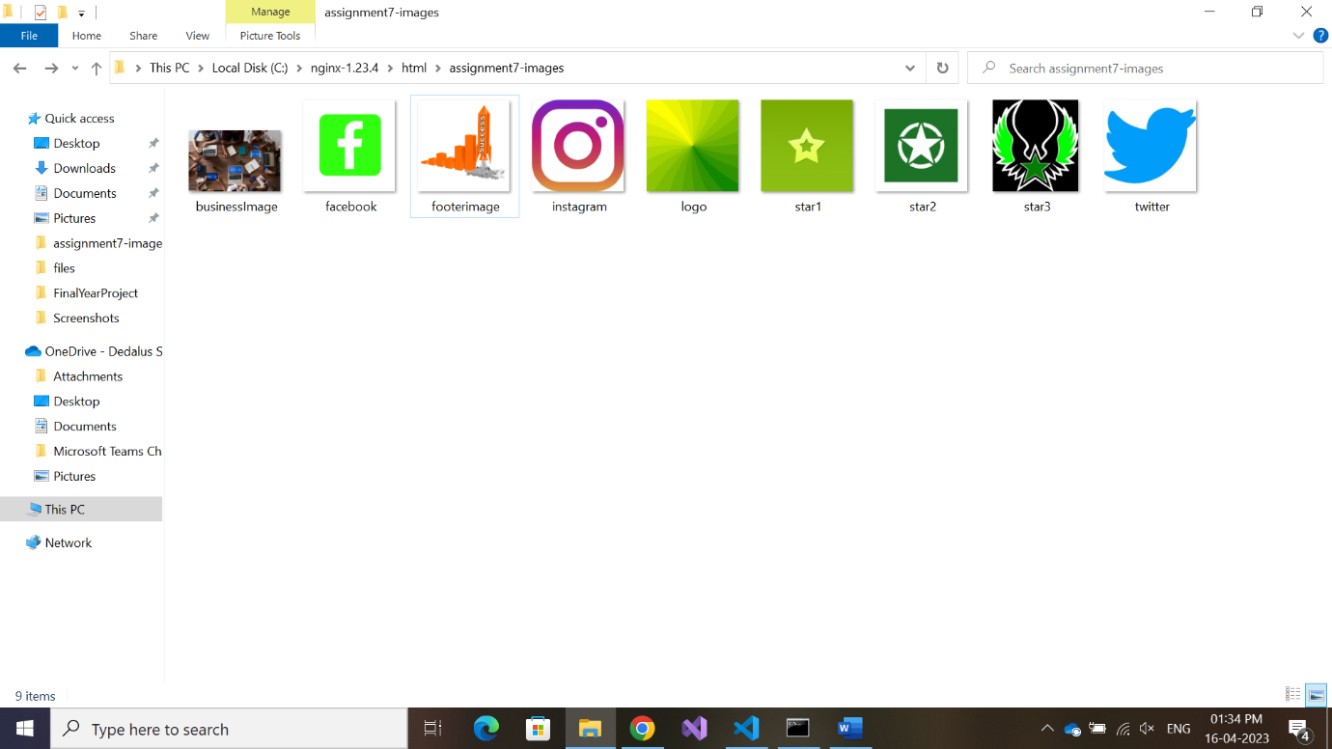

Images are stored inside separate folder created for this project within html folder present in nginx folder.